AI Assistant Coding
Lab 5: Advanced Prompt Engineering

Name: Mupparapu Ganesh Kumar
HT No.:2303A51358
Batch:20
Objective :
• To explore ethical risks associated with AI-generated code
• To understand concerns related to security, bias, transparency, inclusiveness, and copyright in AI systems
• To critically analyze AI-generated code instead of blindly accepting it
• To promote responsible and ethical use of AI tools in software development
Task 1: Privacy and Data Security in AI-Generated Code
AI-generated login code:
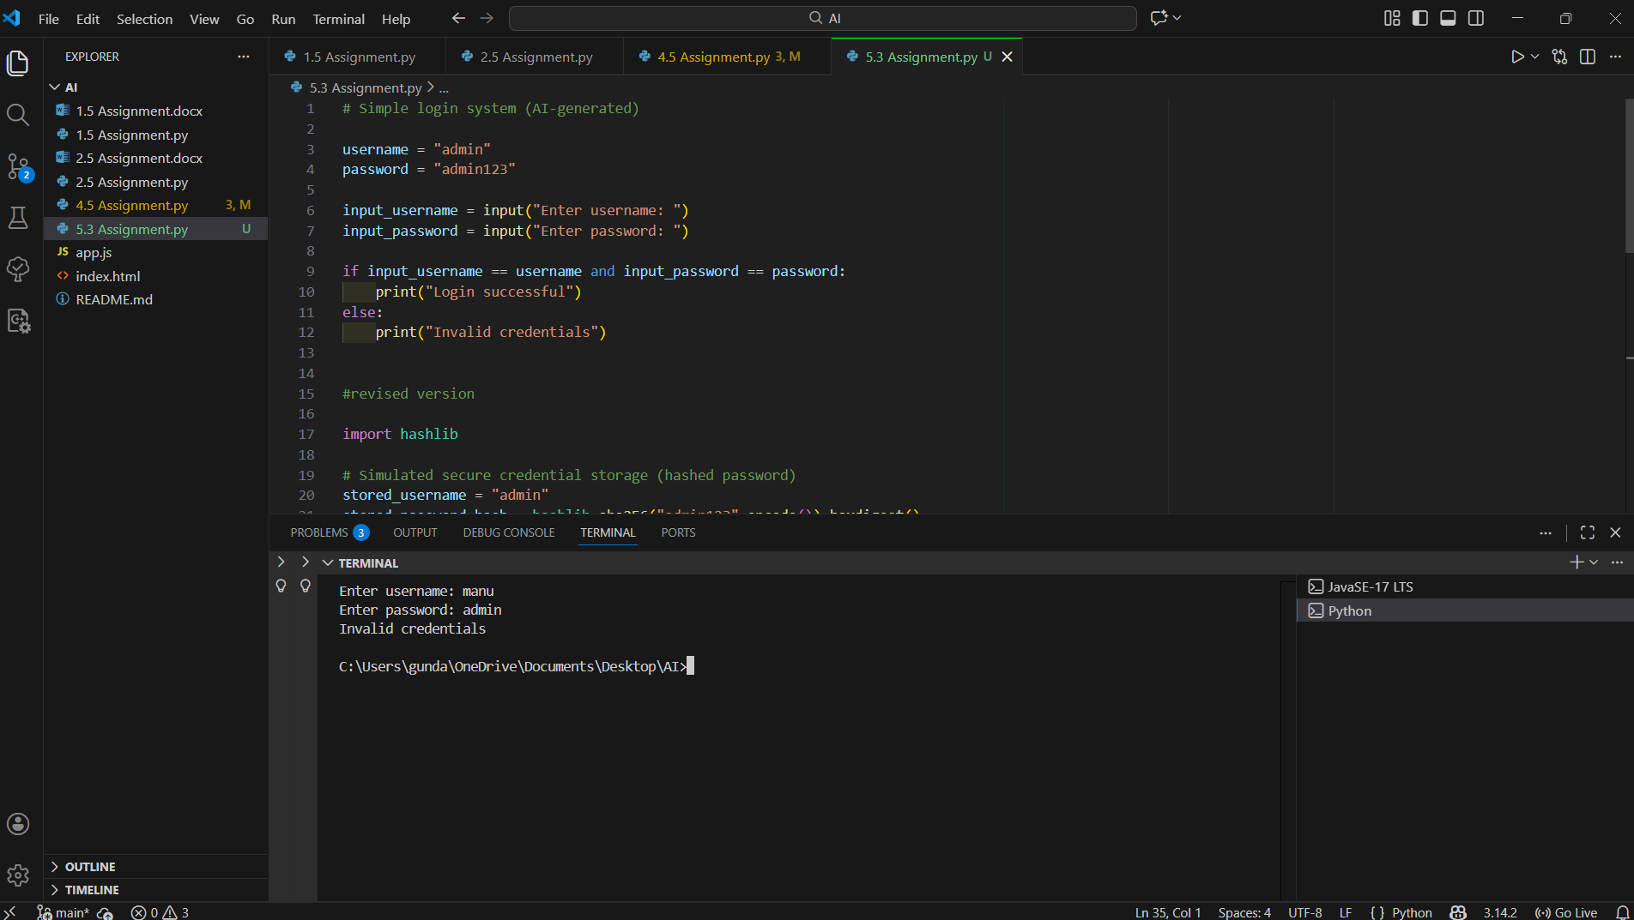
Revised version :
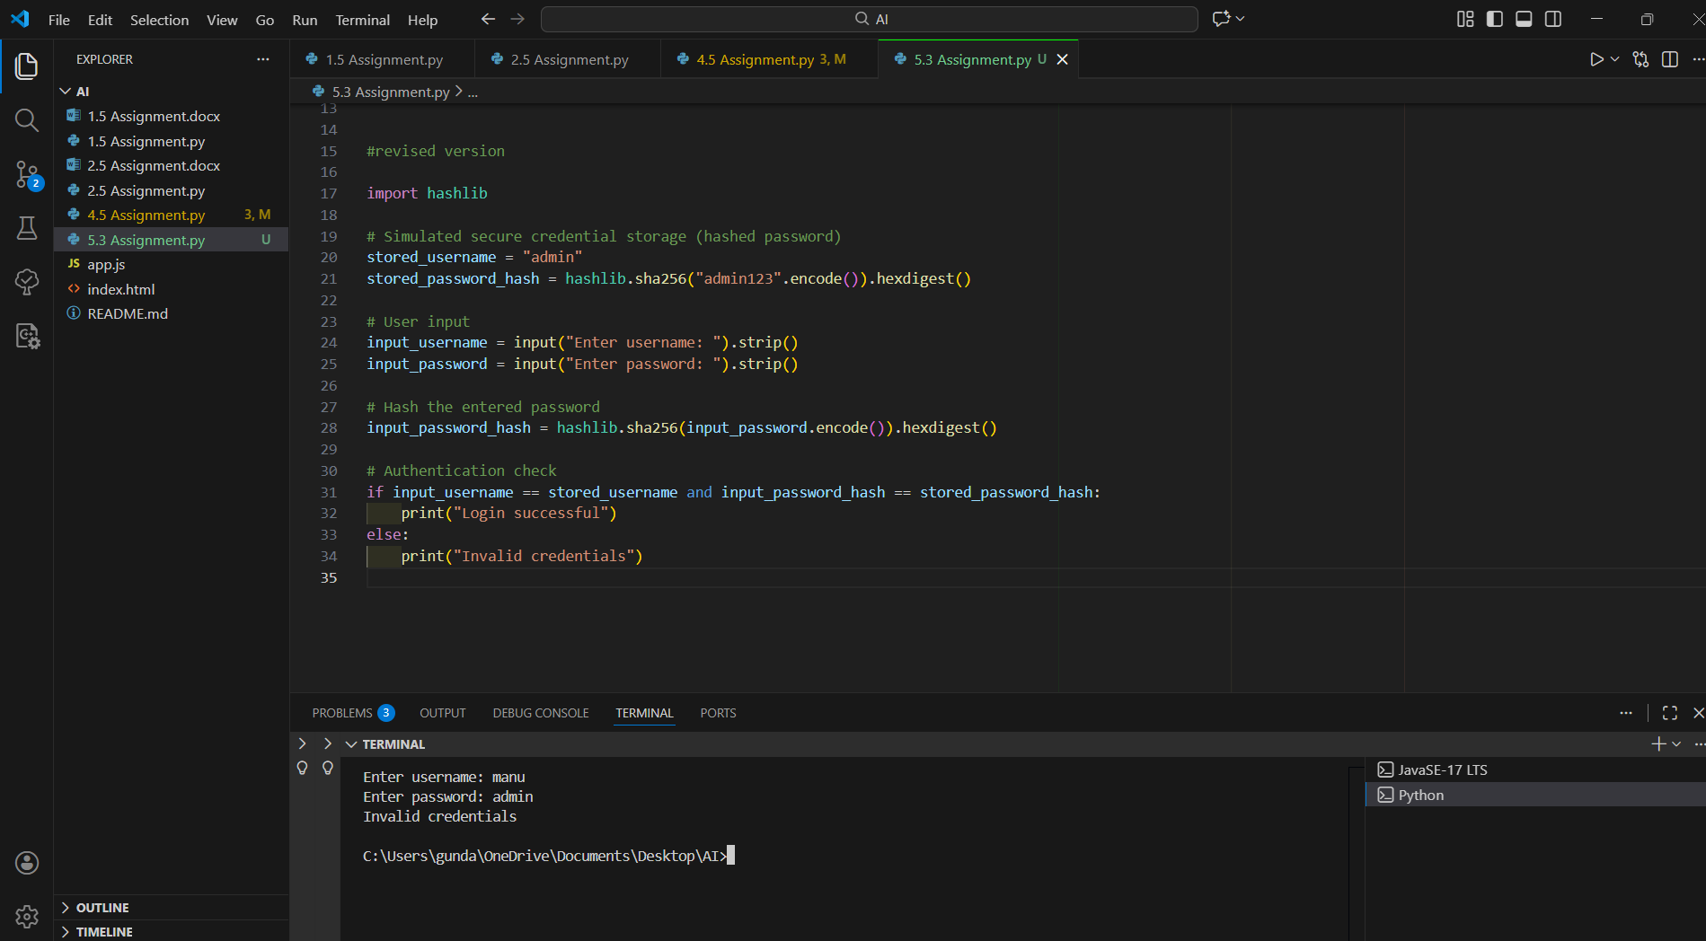
Explanation of Improvements :
The revised version removes hardcoded credentials, ensuring that sensitive information is not directly exposed in the source code. Password hashing is used instead of plain-text storage and comparison, which protects user passwords even if the data is compromised. Basic input validation has been added to prevent incorrect or malicious inputs. Overall, these changes improve the security and reliability of the authentication process.
Task 2 : Bias Detection in AI-Generated Decision Systems
AI-Generated Loan Approval Code :
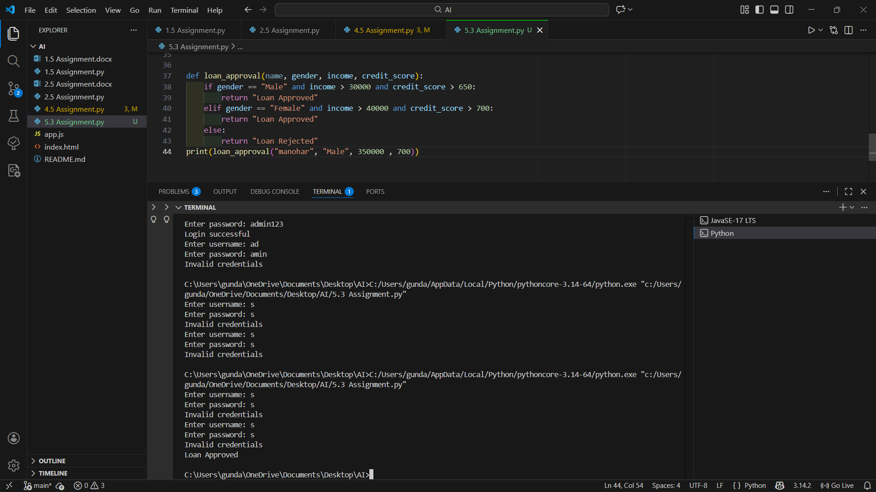
Identification of Biased Logic :
• Loan approval criteria differ based on gender
• Female applicants are required to have higher income and credit score
• Gender and name are treated as decision-making factors
• Logic introduces unfair discrimination
Discussion on Fairness Issues :
The above system is biased because loan approval depends on personal attributes such as gender, which are irrelevant to financial eligibility. This violates fairness and ethical principles, as applicants with similar financial profiles may receive different decisions solely based on gender. Such bias can lead to discrimination and loss of trust in AI systems.
Mitigation Strategies
• Remove gender and name from decision logic
• Base decisions only on financial attributes such as income and credit score
• Regularly audit AI systems for biased outcomes
• Use fairness-aware algorithms and ethical guidelines
• Test systems with diverse and balanced datasets
Revised Bias-Free Loan Approval Code :
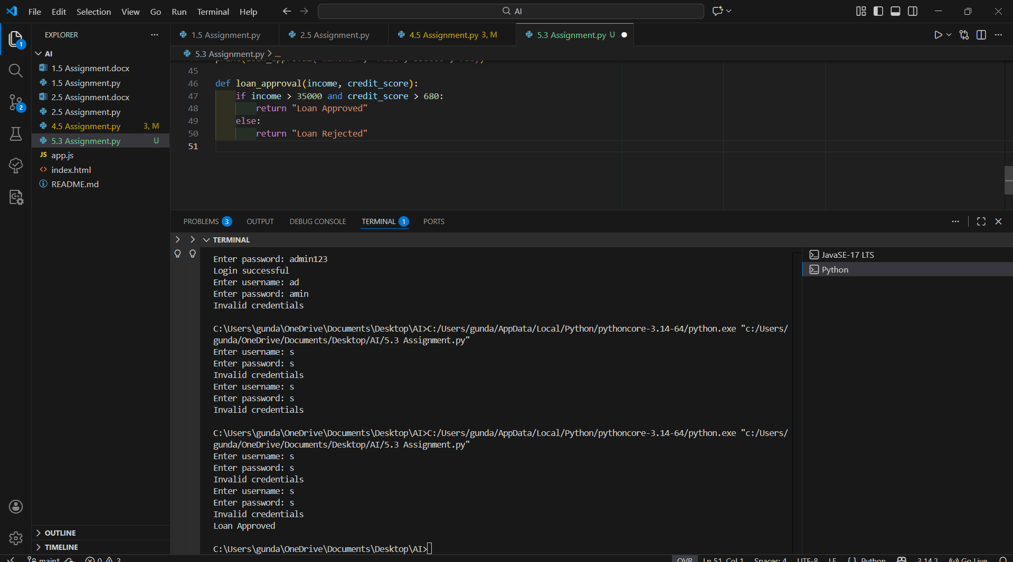
Conclusion :
This task demonstrates that AI-generated decision systems can unintentionally introduce bias. Careful analysis, ethical review, and removal of irrelevant personal attributes are essential to ensure fairness, inclusiveness, and responsible AI usage.
Task 3: Transparency and Explainability in AI-Generated Code (Recursive and Binary Search)

AI-Generated Explanation of Recursive Logic :
Binary Search works on a sorted list by repeatedly dividing the search space into two halves.
The base case occurs when the left index becomes greater than the right index, indicating that the element is not present in the list.
In each recursive call, the middle element is compared with the target value. If the target matches the middle element, the search ends successfully. If the target is smaller, the function recursively searches the left half of the list. If the target is larger, it searches the right half. This process continues until the element is found or the search space is exhausted.
Student’s Assessment :
Clarity :
The explanation clearly describes how binary search works and explains both the base case and recursive case in simple terms.
Correctness :
The logic of the binary search algorithm is correctly implemented using recursion, and the conditions for searching left or right halves are accurate.
Transparency :
The inline comments match the code logic, making it easy to follow. The program is well-documented and understandable for beginner-level students.
Conclusion
This task demonstrates that AI-generated code can be transparent and explainable when clear comments and logical explanations are provided. Proper documentation helps beginners understand recursive algorithms and allows humans to verify the correctness of AI-generated programs.

Task 4: Ethical Evaluation of AI-Based Scoring Systems

Identification of Potential Bias :
• Gender is directly used as a scoring factor
• Male applicants receive additional points unfairly
• Name and gender are unrelated to job performance
• Scoring logic is not fully objective
Ethical Analysis of the Scoring Logic
The scoring system introduces bias by assigning extra points based on gender, which is an irrelevant personal attribute. Such logic can lead to unfair hiring decisions and discrimination, violating ethical principles of fairness, equality, and inclusiveness. AI systems used in recruitment should evaluate candidates solely on job-related qualifications such as skills, experience, and education.
Revised Fair and Objective Scoring System :
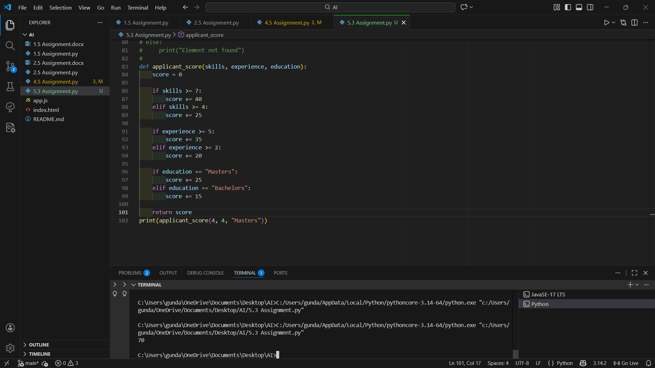
Conclusion :
This task highlights the importance of reviewing AI-generated scoring systems for bias. Removing unrelated personal attributes and focusing only on job-relevant factors ensures ethical, fair, and transparent hiring decisions.
Task 5: Inclusiveness and Ethical Variable Design
Original AI-Generated Code Snippet:
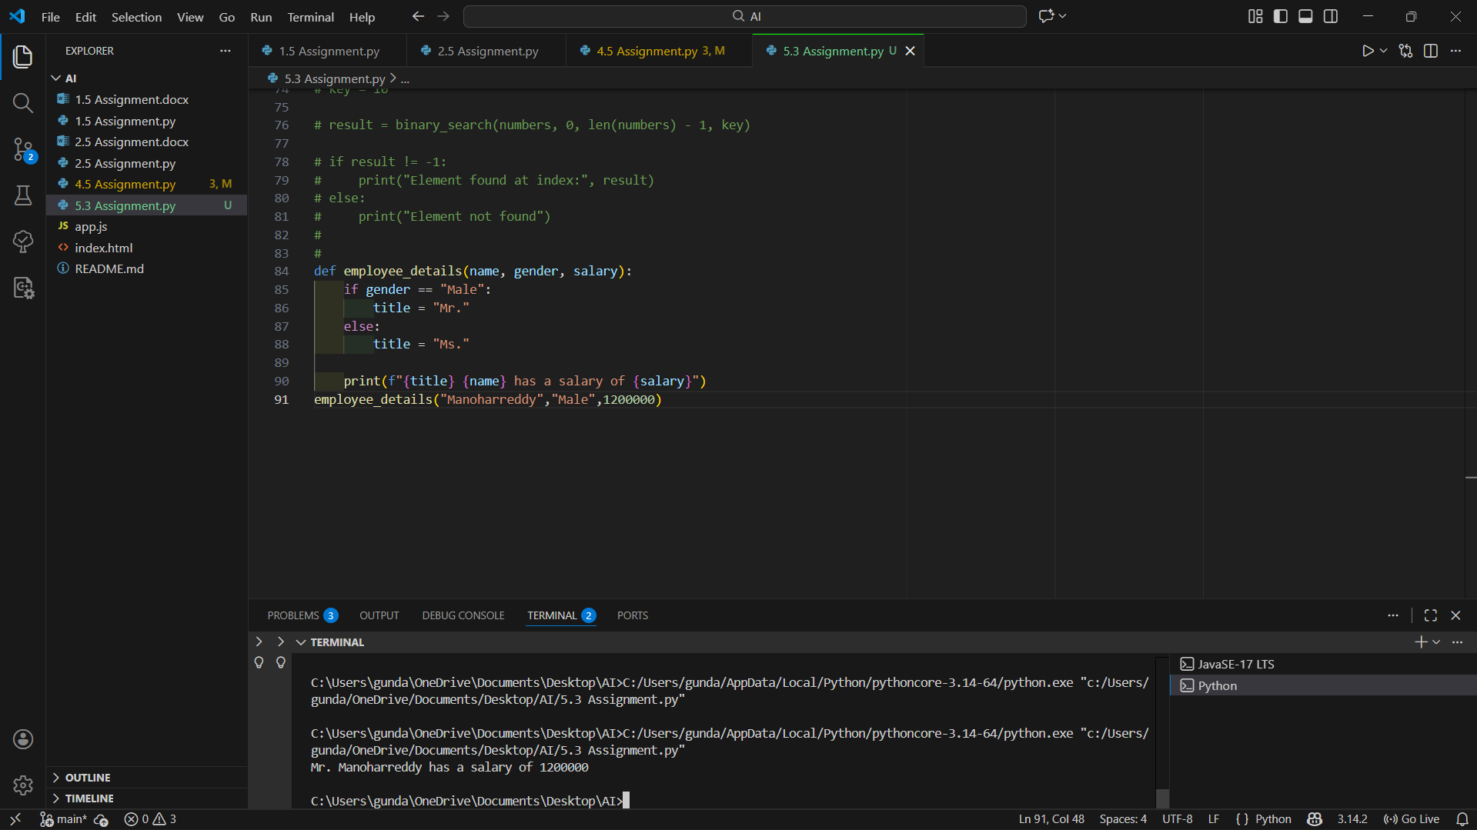
Identification of Non-Inclusive Elements :
• Use of gender-specific variable gender
• Assumption that gender is binary (Male/Female)
• Assignment of titles based solely on gender
• Logic excludes non-binary or unspecified identities
Revised Inclusive and Gender-Neutral Code :
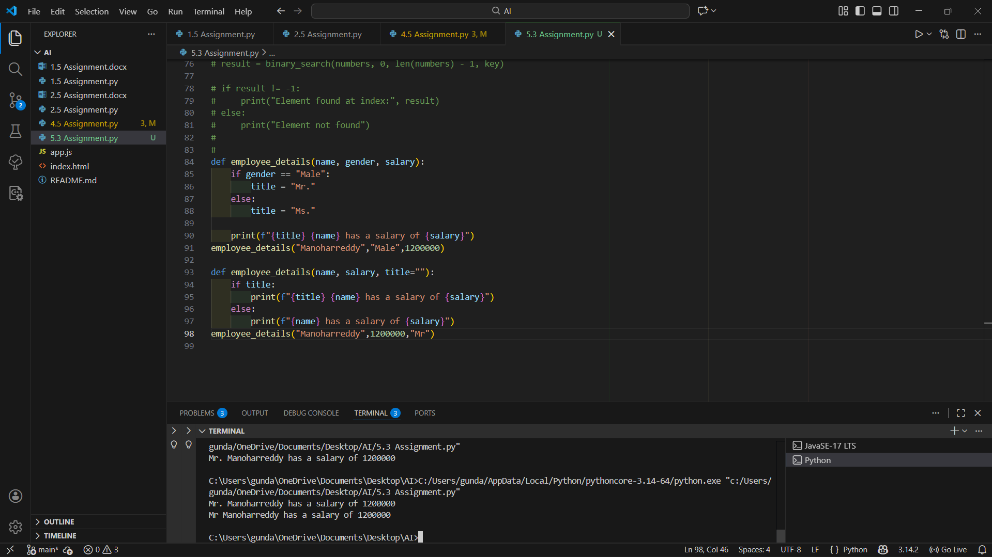
Explanation of Improvements :
The original code was non-inclusive because it assumed binary gender identities and automatically assigned titles based on gender. The revised version removes gender-based conditions and uses optional, user-defined titles instead. This ensures respectful, inclusive, and gender-neutral coding practices while making the software accessible to all users regardless of identity.
Conclusion
This task demonstrates the importance of reviewing AI-generated code for inclusiveness. By avoiding assumptions and using neutral logic, developers can design ethical and respectful software systems.

